CitiBike Data for New York City in 2020:There were 336802 bike trips in NYC throughout. It appeared to be more than 10% ridership increase in summer and peaked in August and September.

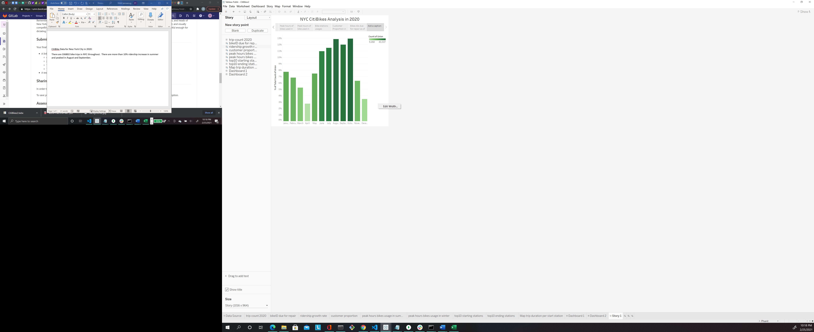

We saw one peak of riders in the evening around 6:00pm during summer months.

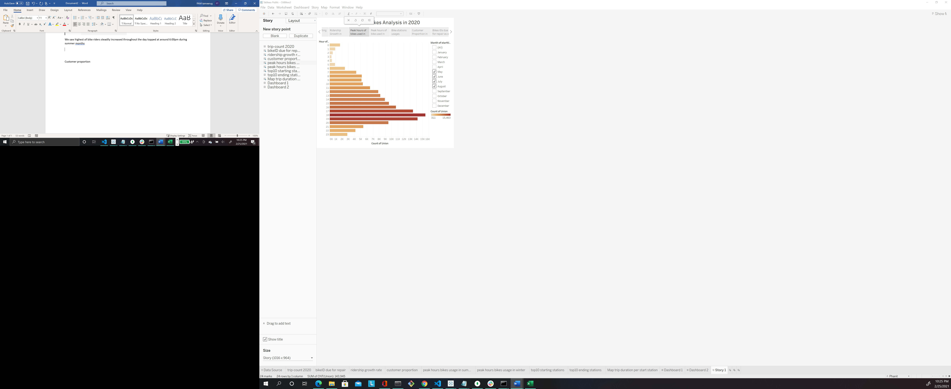

In winter, we saw morning peak hour at 8:00am and afternoon peak hour at 5-6 pm.

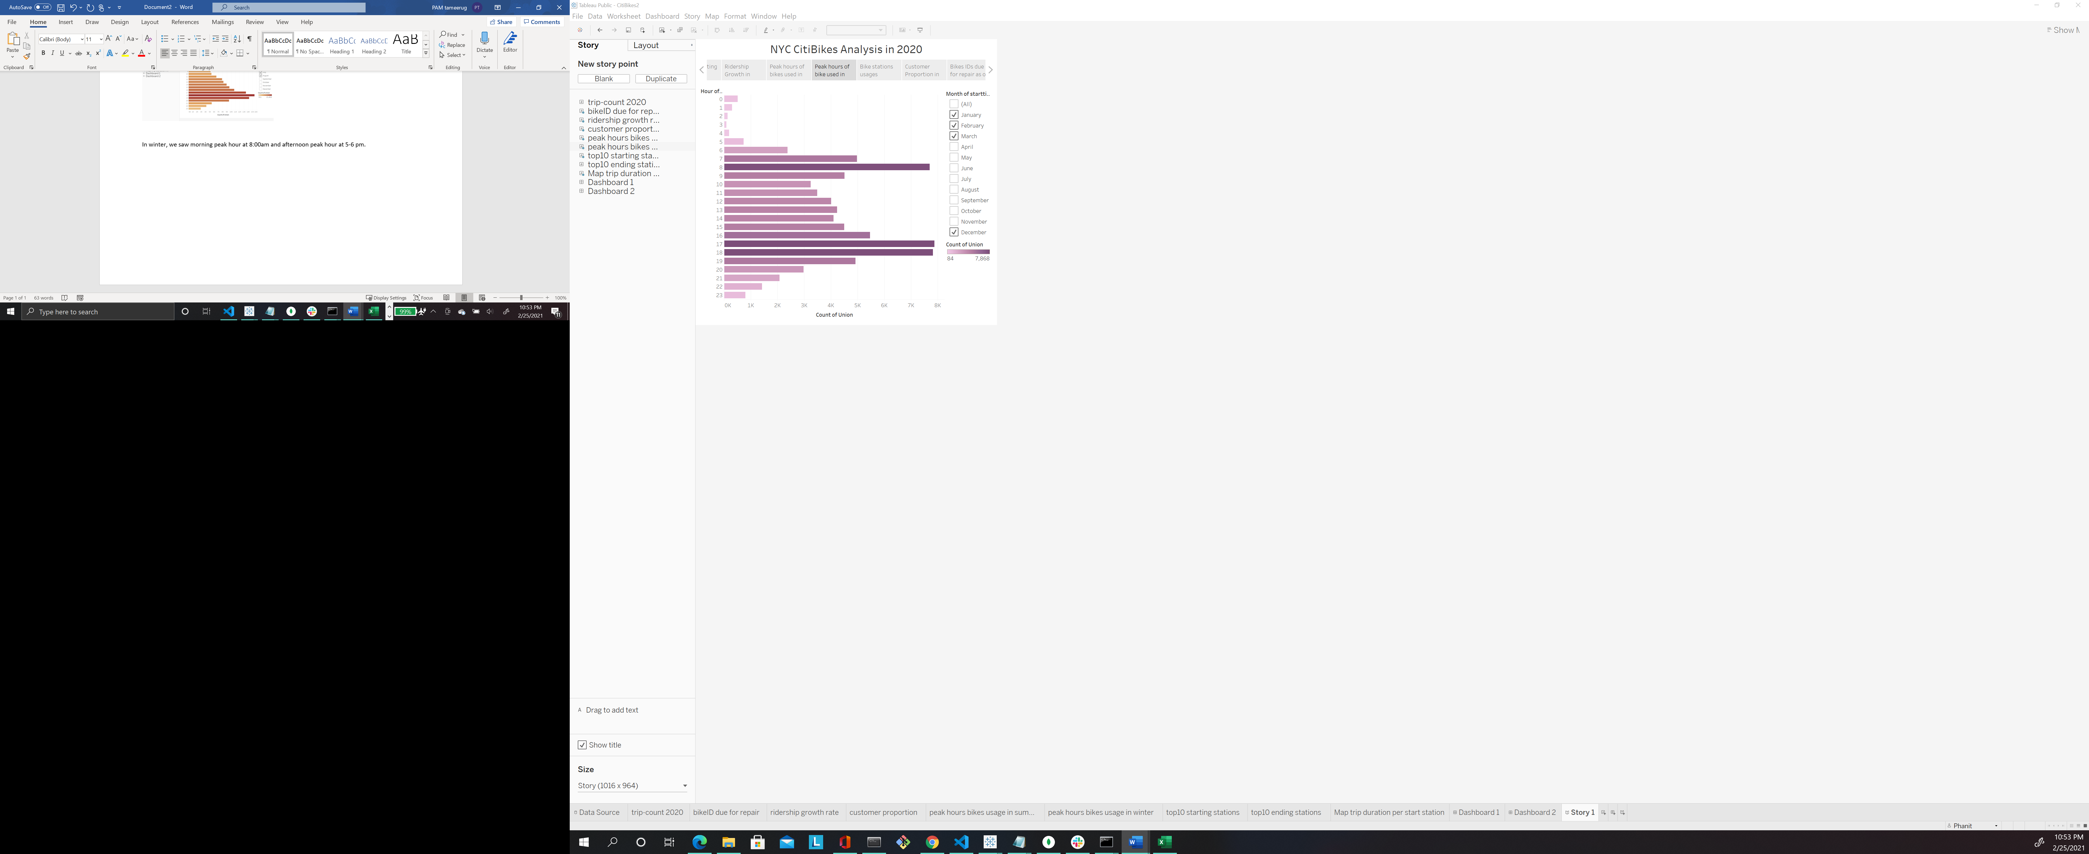

Top 10 start station and top 10 end station were not identical.

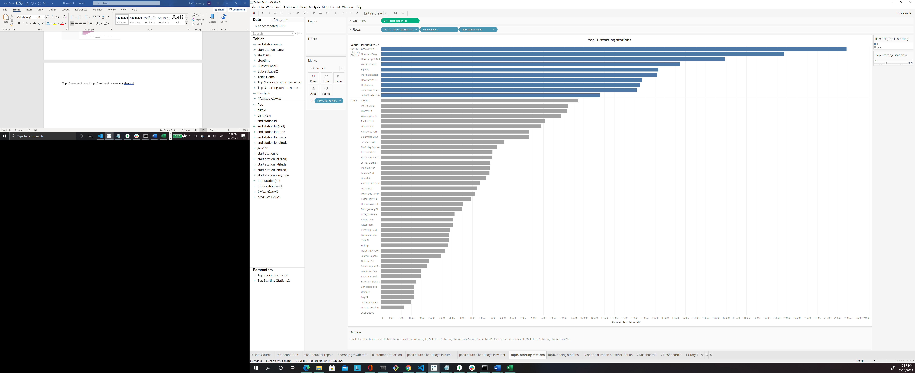

There is longer bike duration near Liberty State Park.

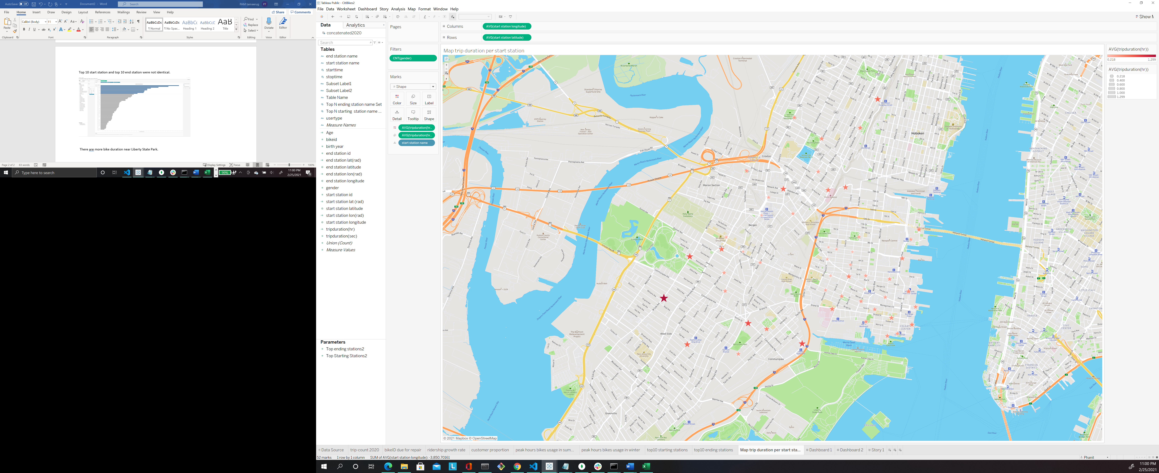

Dashboard1

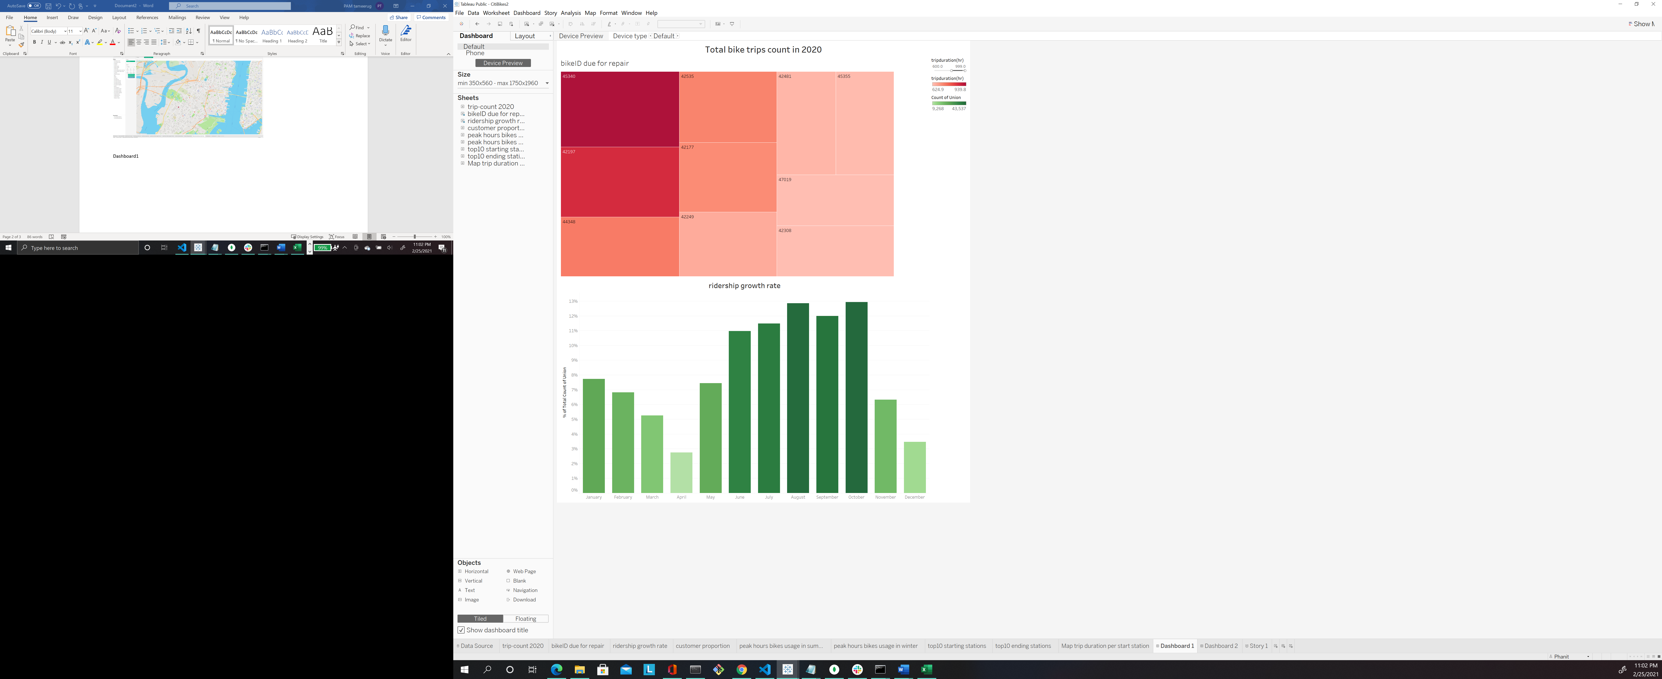

Dashboard2

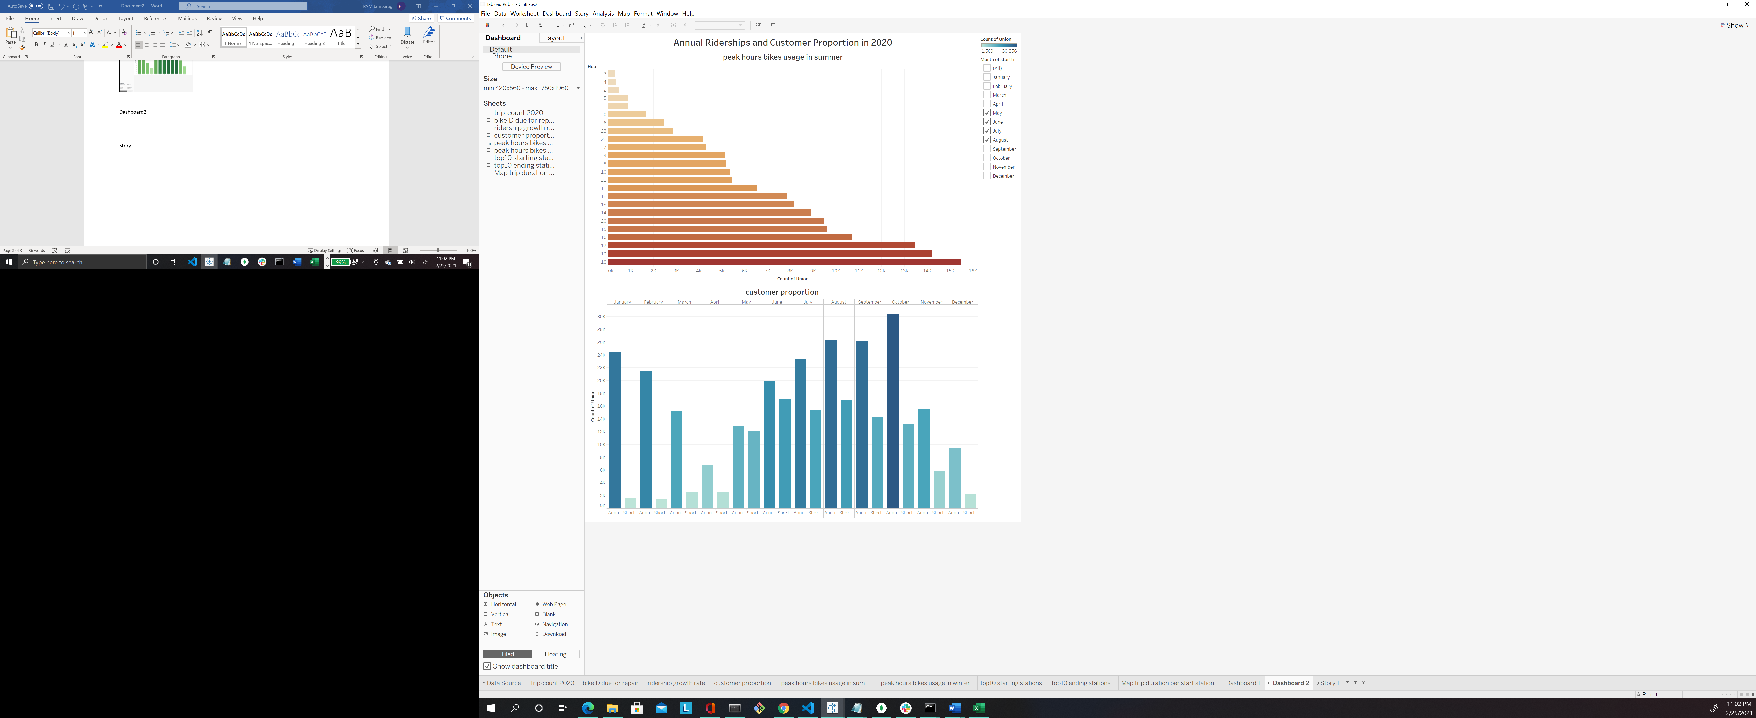

Story

